**How to open PEGA PRPC Application:**

**Step1: Start the Server ( Click on PEGA Platform 8.4.0 Startup Icon)**

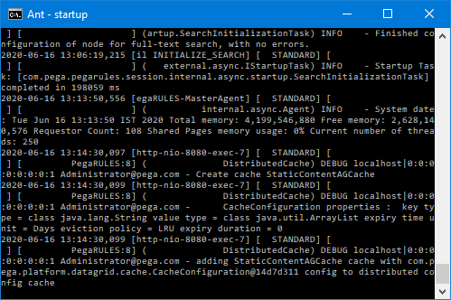

**Step2: Click on PEGA Platform 8.1.0 Login Icon**

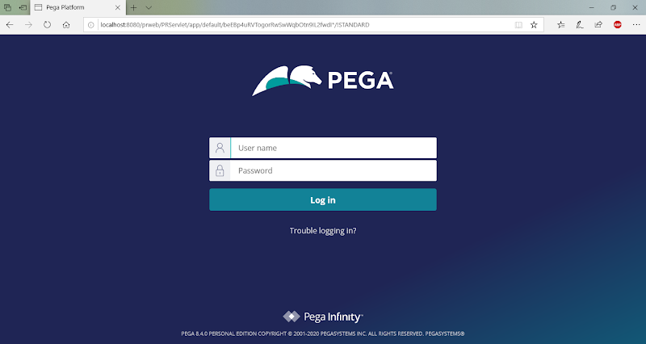

**Login into Application:**

**UserName: Administrator@pega.com , Password: install ( Password give in Lowercase)**

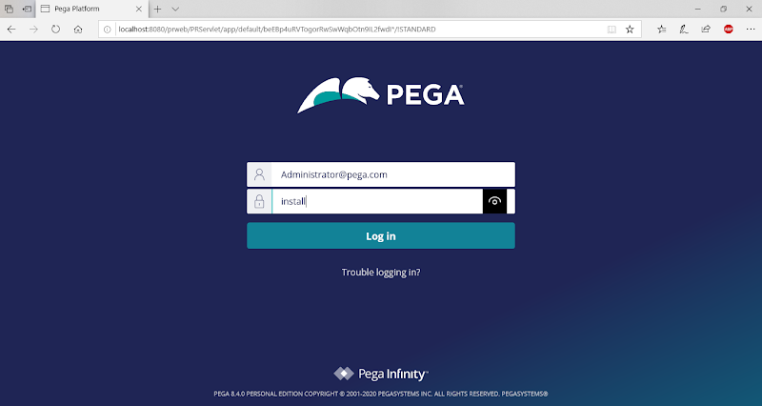

**Click on Login**

**------**

**PRPC Platform/PEGA DEV Studio/ Developer Portal/Pega Infinity:**

**PRPC is an Application to Develop Other Applications. In Enterprise applications the Application Layer architecture will be like Frame Work and Implementation(s).**

**Till  7 Version- After Opening Application - PEGA Designer Studio**

**From  8 Version- After Opening Application - PEGA Dev Studio**

**----**

**Till  7 Version Pega is called as PEGA PRPC**

**From 8 Version Pega is called as PEGA PRPC/PEGA Infinity**

**===========**

**Types of Panels in Portal:**

1. **Header Panel : Internal Settings, Wizards/Tools**
2. **Explorer Panel: Main Application Templates, Data Tables, Case Types**
3. **Work Area Panel:  To Create & Modify rules**
4. **Toolbar/Footer Panel: Internal Tools**

**Types Of Applications/Application Structures in PEGA:**

**1- Framework : means Reusable application**

**2- Implementation: new application design we add under implementaion**

**Built in Framework: PEGA Platform ( Base Framework)**

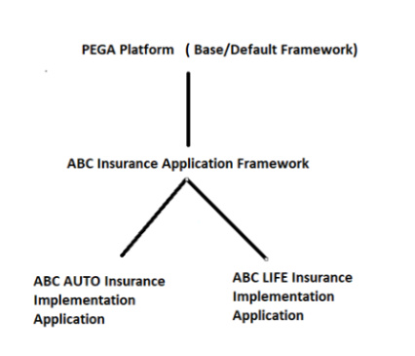

**What is Framework & Adv of Framework?**

**Framework is a Built in Application.**

**Advantage: Reusability**

**============**

**Creating New Framework & Implementation Application:**

**Wizard: New Application Wizard ( From 7 Version)**

**Before 7 Version to add new application the wizard name is DCO ( Direct Capture of Objectives)**

**Under DCO u will have 2 Tools- > Application Profiler & Application Accelerator**

**First Add Framework Application: (ALFA Insurance Application)**

**Create New Framework Application from Application Menu( Open From Header Panel):**

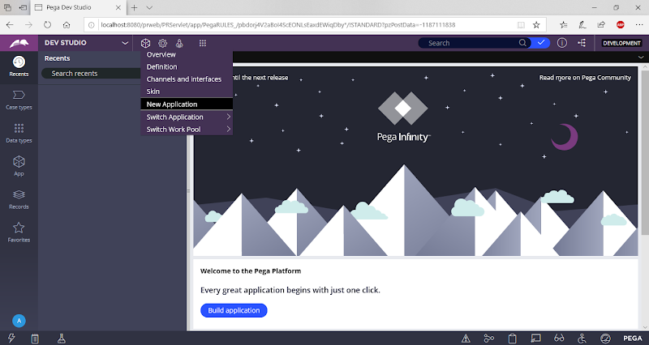

**Click on New Application**

**Or Open New Application Wizard from Work Area Panel -> Click on Build Application**

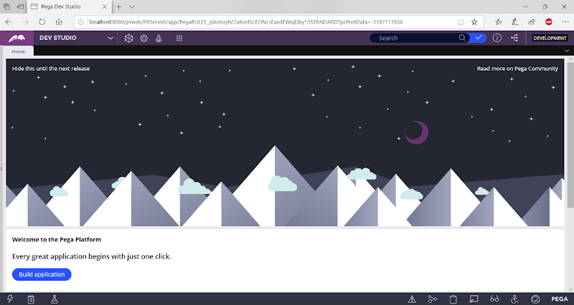

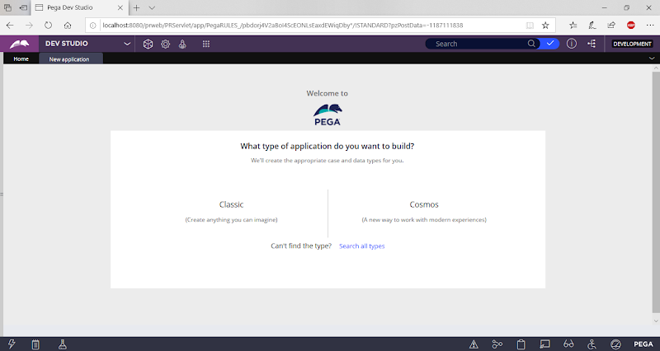

**Click on Classic:**

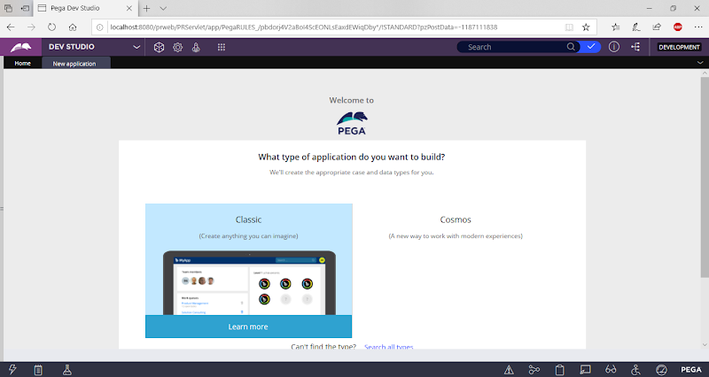

**Click on Classic**

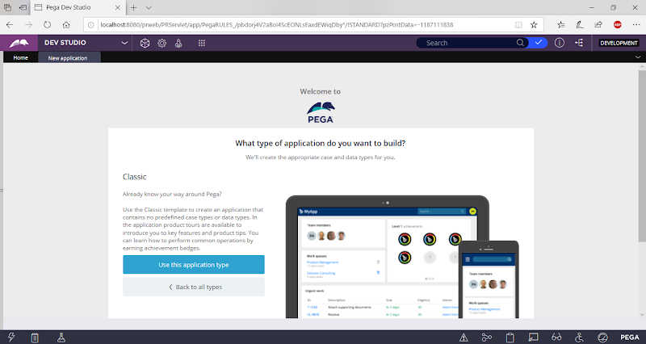

**Click on Use this Application Type:**

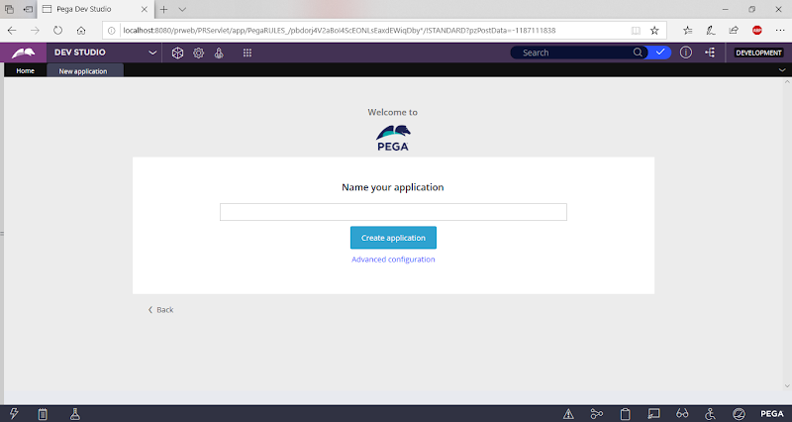

**Give Framework Application Name: ALFA Insurance Application**

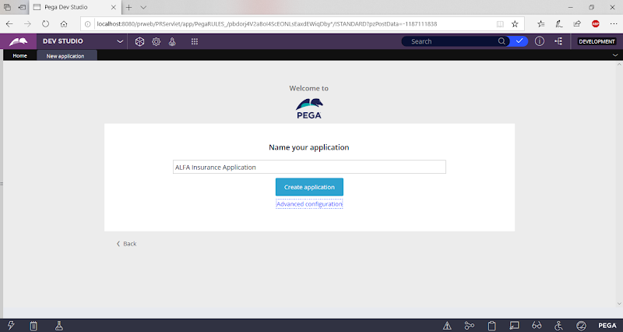

**Click on Advanced Configuration Link**

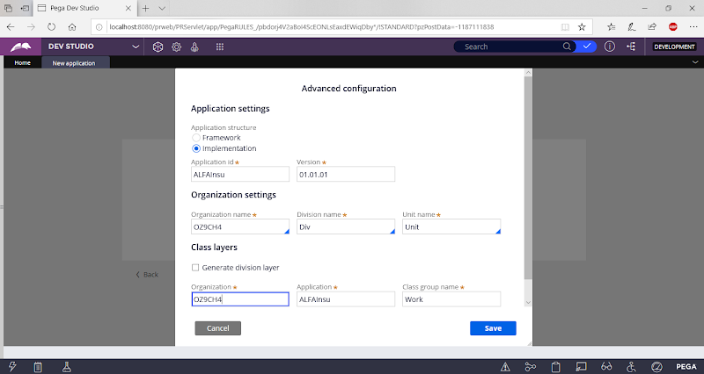

**Update Application Structure to: Framework**

**Update Organization name: ALFA**

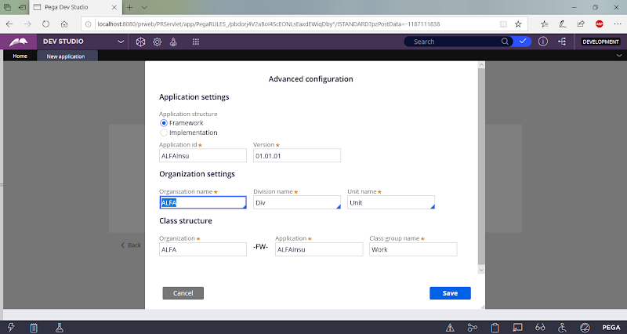

**Click on Save**

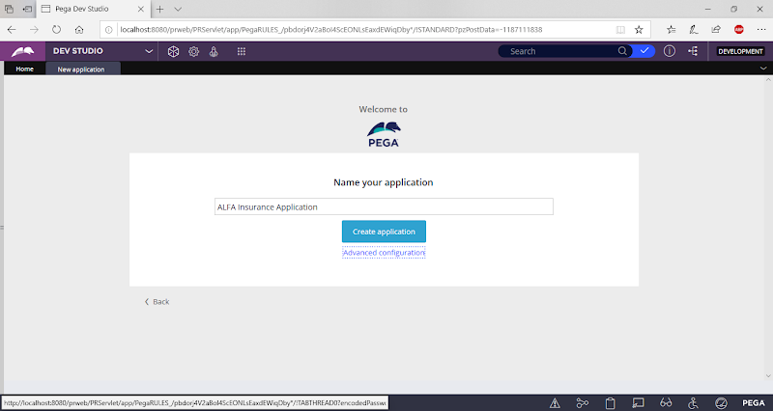

**Click on Create Application**

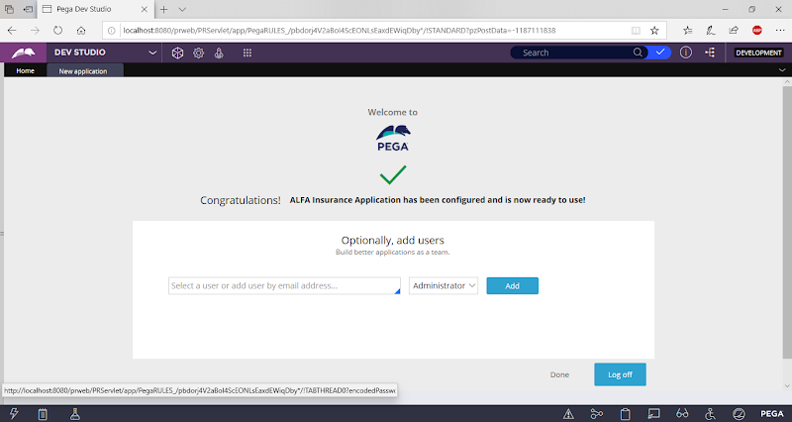

**Add User ID/ Operator Id: Admin@ALFA**

**Add User ID & Click on Add**

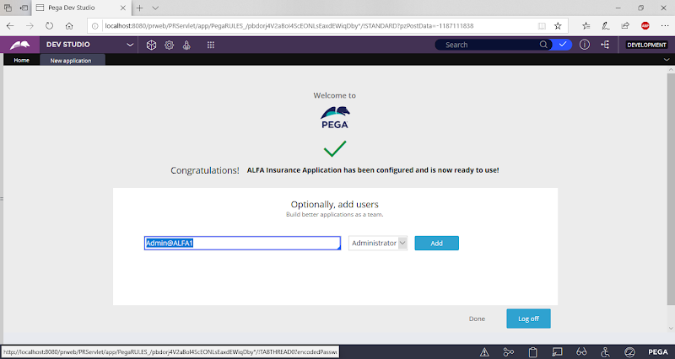

**Click on Add**

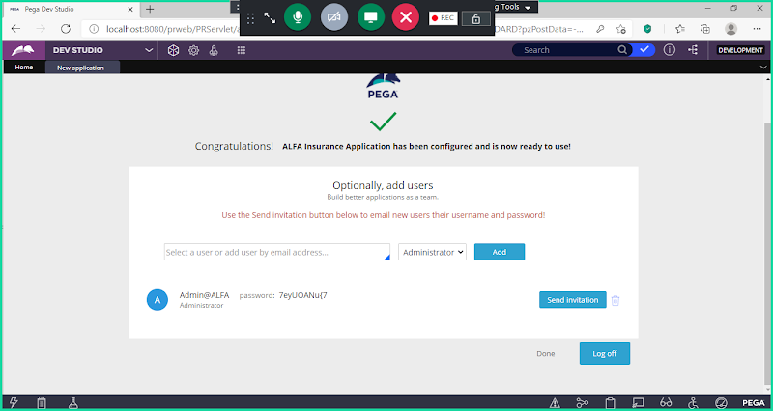

**Note your password:** {W.qliy6ZW

**Now logoff & Login with :**

**Admin@LIC**

**Enter Password : Lucy**

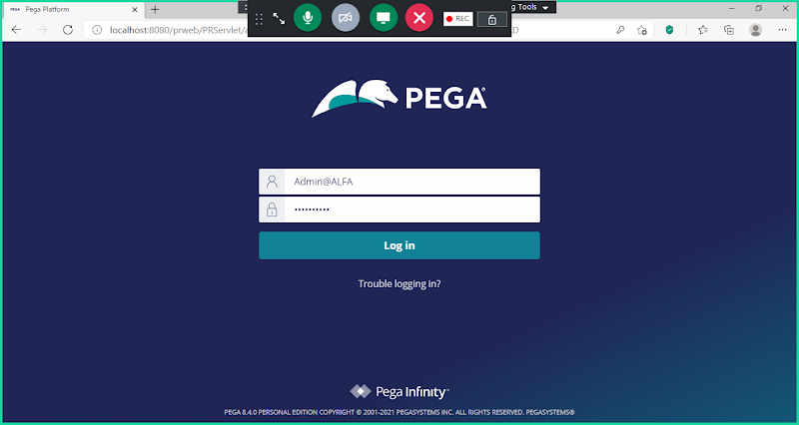

**Login**

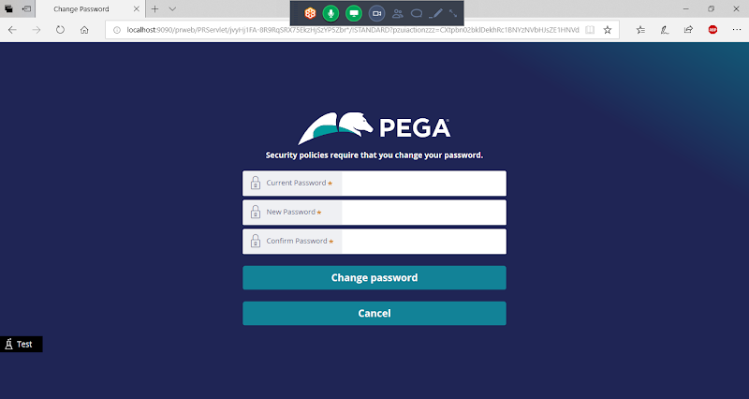

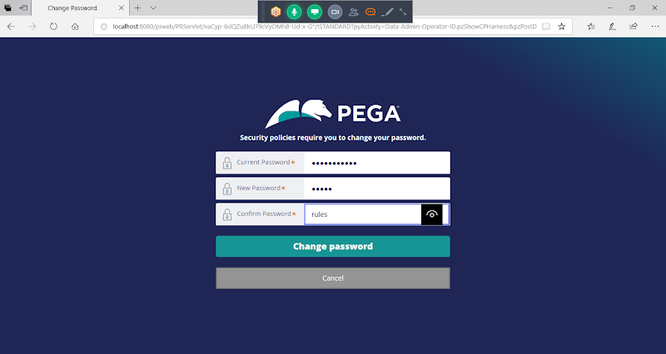

**Change Password**

**New Password: rules**

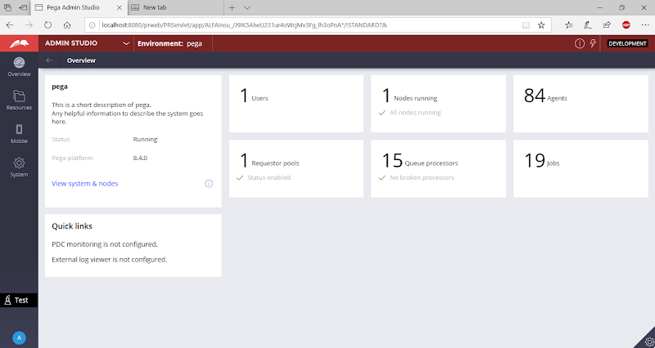

**Now Switch to Dev Studio:**

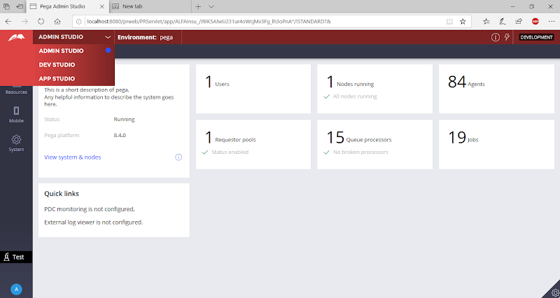

**Select Dev Studio**

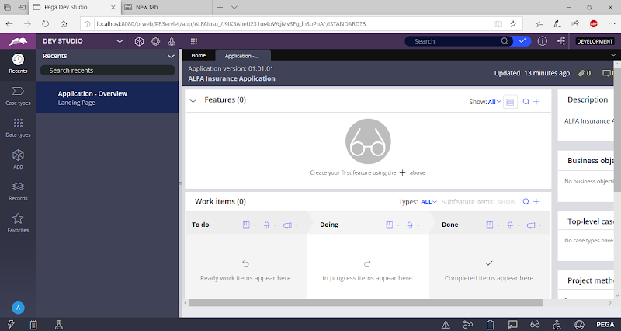

Under Framwework Add Implementation Application ( On Top of ALFA Insurance Application Framework)

**Open New Application Wizard from Application Menu:**

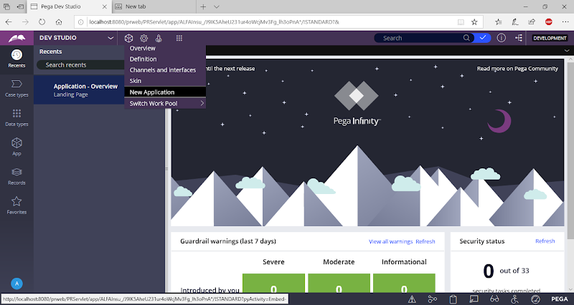

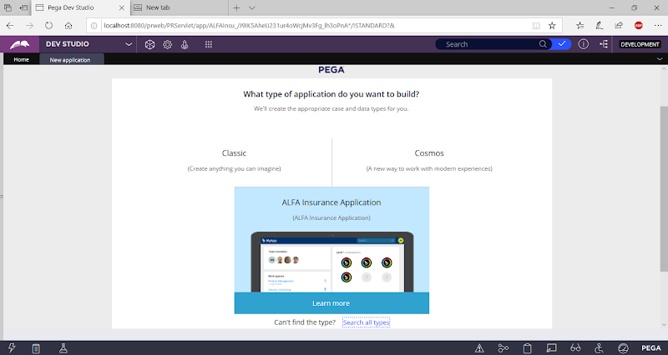

**Click on ALFA Insurance Application Framework**

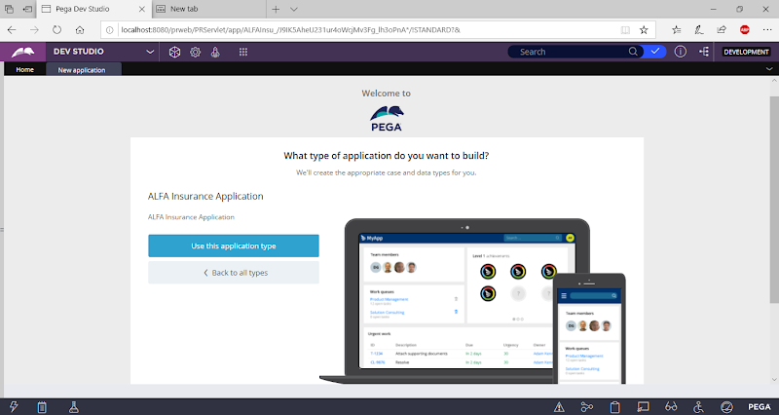

**Click on Use this Application Type:**

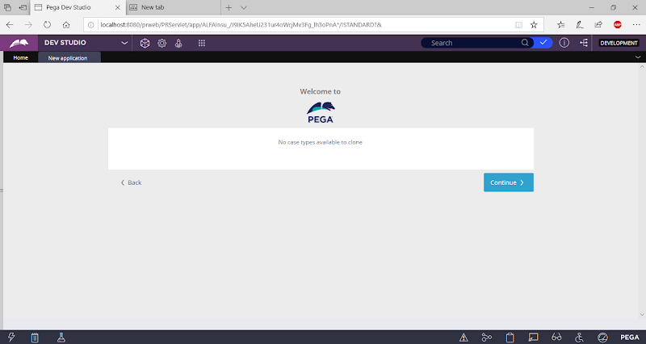

**Continue**

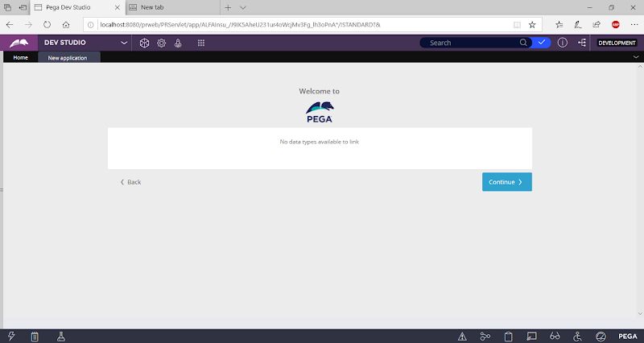

**Continue**

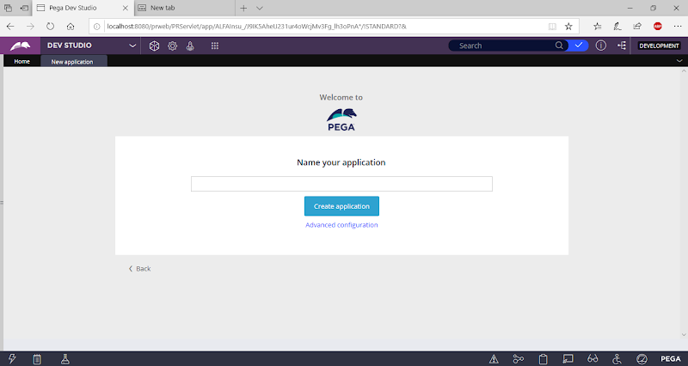

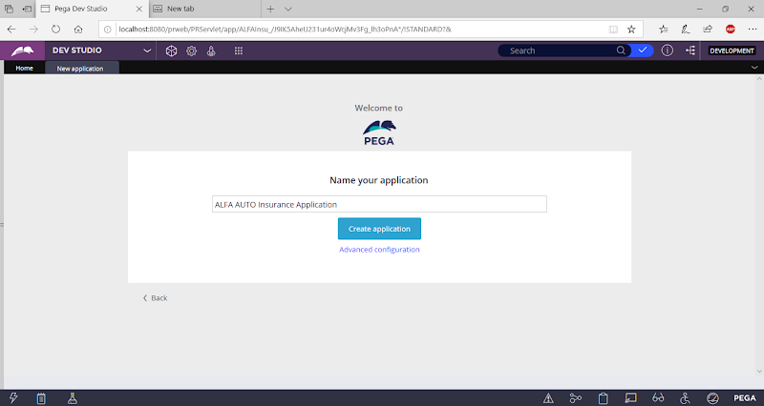

**Optionally you can check your Application structure by Opening the Link ( Advanced Configuration)**

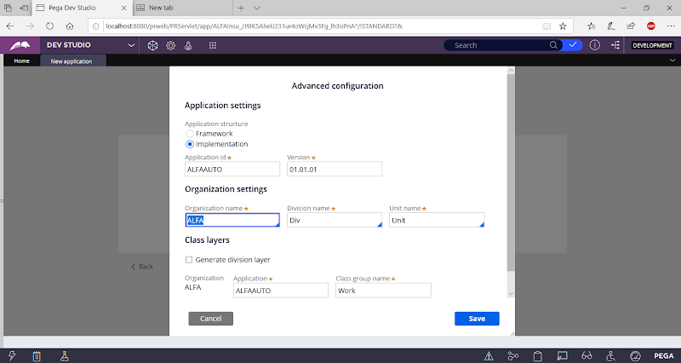

**Click on Save**

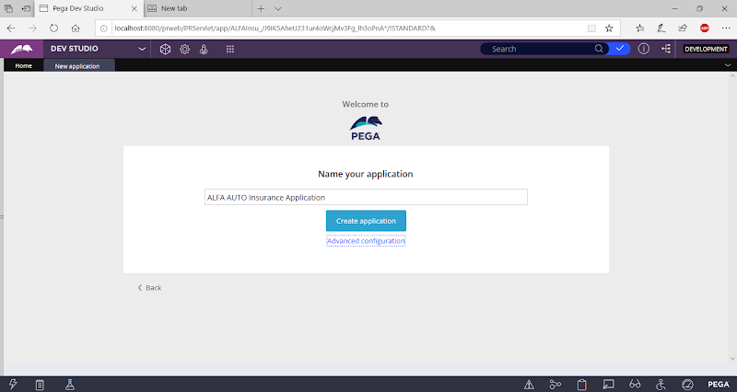

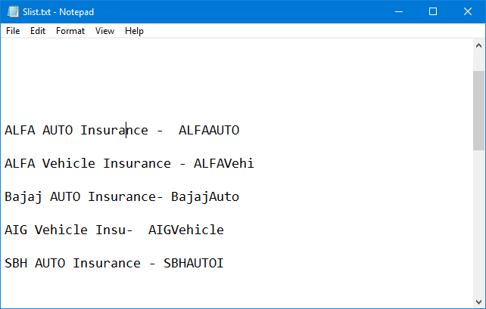

**Organization Name Max Length is 4 Characters/ less than 4 chararcters: ex: ( ALFA, TATA, CITI, BAJA, CAPI, AXA)**

**Application Name/Division Name Minimum length is 8 Characters & Max Length is 10 Characters.**

**Click on Create Application**

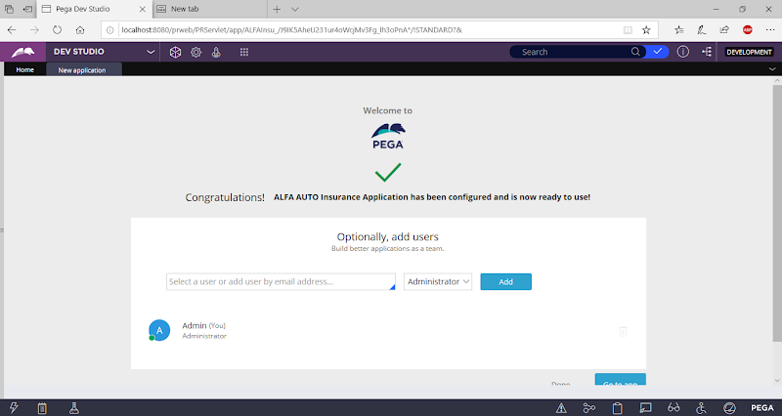

**Click on Done ( It will go to Framework application)**

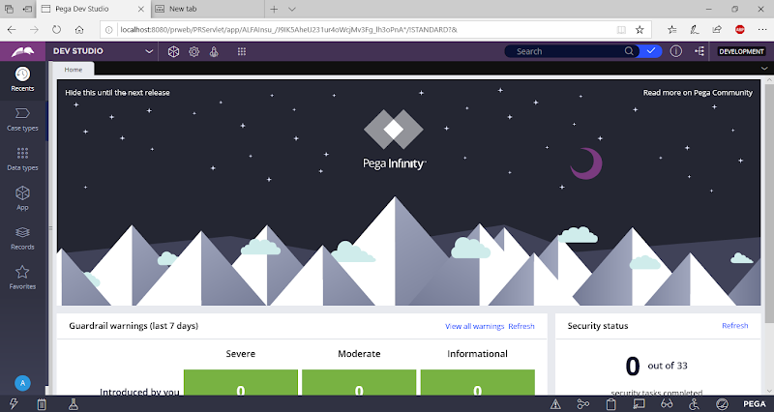

**Logoff & Login**

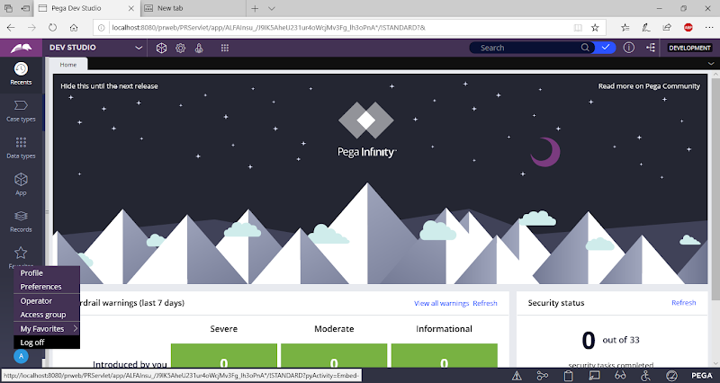

**User ID: Admin@ALFA**

**Password:** **rules**

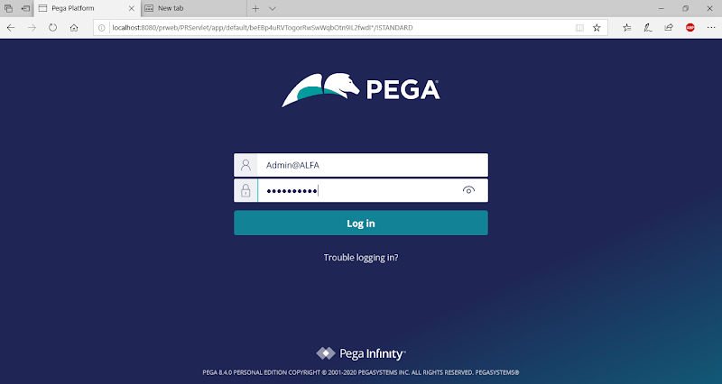

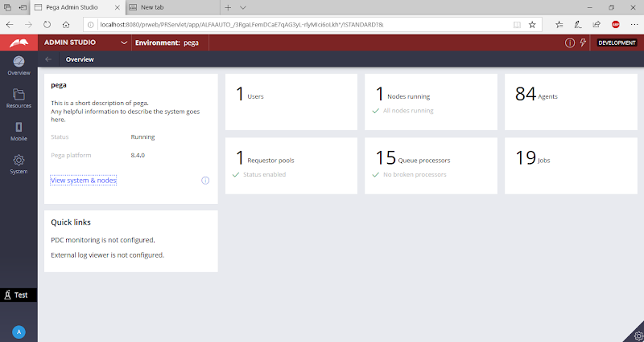

**Go to Dev Studio:**

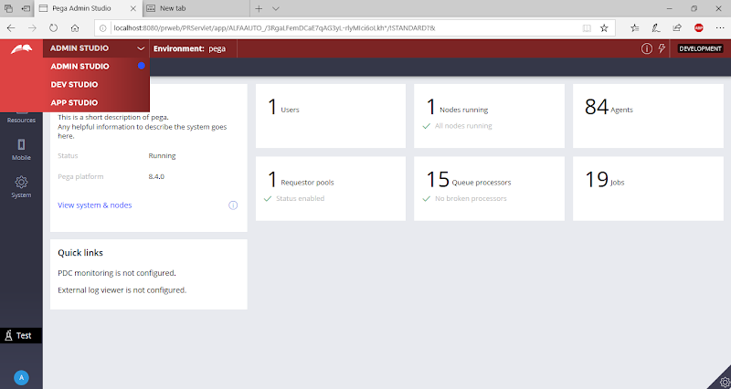

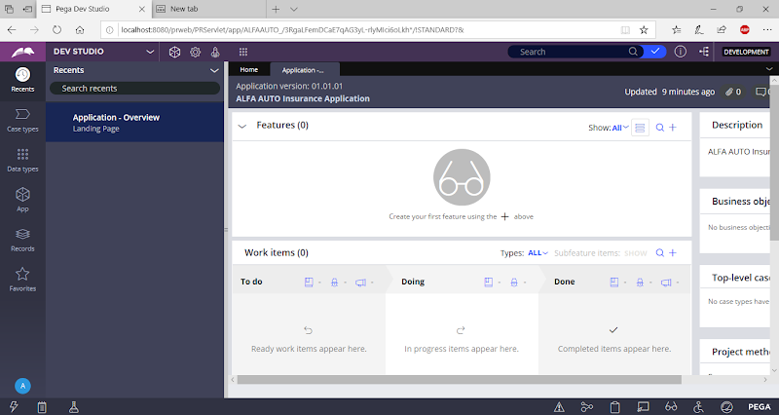

**Now in Explorer Panel -> Click on App Explorer**

**Go to App Explorer:**

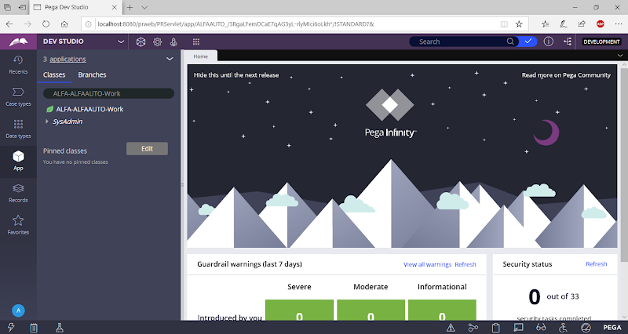

**==========**

**Organization Name: -- Max 4 Characters**

**Ex: Capital -- ( CAPI) - If we give organization name 6 or more characters it will automatically truncate organization name to 4 Characters)**

**Ex: Birla - Birl - If we give organization name 5 characters it will automatically generate organization name with 4 Characters)**

**Ex: AXA - Axa - If we give 3 letters in Org Name it will take same**

**Ex: Geiko- Geik**

**Application Name: 8,9 or 10 Characters**

**EX:   BUPAAUTO ( Division Class)**

**Application Name will be truncated to 8 Characters else in some cases it will truncate to 10 Character**

**Ex: Geiko Vehicle Insurance Application**

**GeikoVeh**

**Ex: Geiko Auto Insurance Application**

**GeikoAuto**

**=====**

**Org Name: SBH**

**App name: SBH Vehicle Insurance  : SBHVehicle ( 10 Char)**

**App name: SBH Auto Insurance  : SBHAutoI  ( 8 Char)**

**App name: HDFC Auto Insurance: HDFCAuto ( 8 Char)**